

A Comparative Backtesting Study of Machine Learning and Rule-Based Trading Strategies in Cryptocurrency Markets
Group Members:
Name | Matriculation Number
Lau Ming Jie | A0272632H
Loo Wen Wen | A0259594J
Low Ruo Fei Evie | A0259605X
Wilbert Christopher Kurniawan | A0282267X
Wu Xuande | A0287897W

GitHub Repository: https://github.com/xdewu0508/QF4211Project
1. Introduction 3
2. Literature Review 3
2.1. Traditional Technical Trading in Cryptocurrency Markets 3
2.2. Machine Learning in Trading 4
2.3 Positioning Our Study 4
3. Data and Preprocessing 5
3.1. Data Source and Assets 5
3.2. Sample Period 5
3.3. Data Construction 6
3.4. Train / Validation / Test Split 6
4. Methodology 7
4.1. Prediction Labelling 7
4.2. Model Explanation 7
4.2.1. Buy-and-Hold Benchmark 8
4.2.2. Rule-Based Technical Heuristics 8
4.2.3. Machine Learning Models 8
4.3 Backtesting Framework 9
4.4 Evaluation Metrics 9
5. Results and Discussion 9
5.1. Overall Performance Comparison 10
5.1. Impact of Transaction Costs 10
5.2. Model-Level Comparison 11
5.3. Feature Representation Analysis 11
5.4. Strategy Behaviour & Trading Characteristics 11
5.5. Statistical Significance 12
5.6. Equity Curve Analysis 12
6. Limitations 13
7. Conclusion 13

Introduction
Cryptocurrency markets have evolved rapidly, outpacing traditional valuation frameworks and creating an environment where assets lack conventional fundamentals such as cash flows or earnings. As a result, traders rely heavily on price action, volume, and technical indicators to navigate a highly volatile, 24/7 market. While traditional technical analysis (TA) uses rule-based heuristics like moving averages and Relative Strength Index (RSI), machine learning (ML) and deep learning (DL) offer the potential to capture complex, non-linear patterns in market behavior. However, a critical gap remains between theoretical predictive performance and practical economic viability, as many academic studies emphasize "hit rates" while neglecting transaction costs, which can rapidly erode the profitability of high-frequency algorithmic signals. This study is motivated by the need for a realistic "head-to-head" evaluation between the added complexity of ML and the inherent simplicity of traditional rules in remaining more resilient amidst market frictions. Consequently, this research addresses the following central question: To what extent do ML-based trading strategies outperform traditional rule-based strategies and passive buy-and-hold benchmarks in terms of the Sharpe Ratio, once transaction costs and backtesting constraints are applied to major assets such as Bitcoin (BTC), Ethereum (ETH), Ripple (XRP), and Solana (SOL)?

Literature Review

Traditional Technical Trading in Cryptocurrency Markets
Cryptocurrency markets are relatively unique, characterized by a lack of fundamentals like no earnings or dividends, forcing participants to rely on price-action signals, volume data, and momentum indicators, like SMA and RSI. Hudson and Urquhart (2021) found that technical trading rules produced superior risk-adjusted returns than simply holding the asset. Yet, Liu et al. (2024) noted that these indicators often deviate from traditional asset classes as common tools like RSI tend to act as a trend-continuation signal rather than a mean-reversion one. This implies that parameters calibrated on equity markets may not translate effectively in the crypto ecosystem. A critical factor in determining the viability of these strategies is the integration of transaction costs. Research by Svogun and Bazán-Palomino (2022) found that including fees significantly changes profitability assessments. While previous literature by Ratia (2022) and Anghel (2022) found support for TA strategies, these studies have largely focused on long-only designs, highlighting a literature gap regarding portfolios that incorporate short positions.

Machine Learning in Trading
The use of ML in cryptocurrency trading has expanded considerably since the mid-2010s, with architectures like Random Forest, XGBoost, and Recurrent Neural Network (RNN) being the industry standard. Research by Chatzis et al. (2025) highlights the potential of these models, noting XGBoost and Long Short-Term Memory (LSTM) can produce significant returns and high Sharpe ratios for BTC and ETH. However, a significant caveat remains as these results were generated under zero transaction costs. Among recurrent models, Belalova et al. (2023) found that Gated Recurrent Unit (GRU) tends to outperform LSTM due to its simpler gating structure making it less prone to overfitting, which is critical when working with the relatively limited historical cryptocurrency data. Yet, Jabbar and Jalil (2024) warn that strong in-sample results frequently fail to hold out of sample, with several models underperforming a naive baseline on unseen data. In implementation, our experiment employs a strict chronological split and tests a progression of architectures, from linear Logistic Regression to tree-based XGBoost and LightGBM, and to the temporal depth of GRU.

2.3 Positioning Our Study
The practical utility of cryptocurrency trading models is often limited by the omission of transaction fees, which can turn statistically accurate signals into unprofitable strategies. This issue is compounded by overfitting in the non-stationary cryptocurrency market, as well as a common literature tendency to prioritize accuracy over trading outcomes like net profitability.
Finally, most studies focus exclusively on BTC, leaving the performance on assets with different volatility largely unverified. To address the gaps noted above, our study prioritizes Sharpe-based performance over simple predictive accuracy as the primary evaluation metric. The framework provides a consistent cross-asset assessment across BTC, ETH, XRP, and SOL and explicitly incorporates a 0.035% transaction fee to every unit position change across all strategies. Finally, ML models, rule-based strategies, and a passive benchmark are evaluated under identical conditions across long-only, short-only, and long-short structures.

Data and Preprocessing

Data Source and Assets
The data for this study are sourced from the Binance Public Data archive, utilizing historical candlestick files for the world’s largest cryptocurrency exchange by trading volume. The analysis focuses on four USDT-denominated spot pairs: BTC/USDT, ETH/USDT, XRP/USDT, and SOL/USDT, which were selected to ensure high liquidity, realistic transaction fee structure and negligible price impact. These specific assets also span a diverse range of market characteristics: BTC and ETH represent large-cap assets with institutional participation and relatively lower idiosyncratic volatility, while XRP and SOL exhibit higher beta, sharper drawdowns, and more pronounced regime dependence. With a continuous five-year hourly dataset, our study avoids common survivorship biases while testing whether any performance advantage is broadly generalisable across different structures.

Sample Period
The dataset spans approximately five years of hourly observations from 4 January 2021 to 31 December 2025, yielding 43,736 hourly bars per asset. This window was chosen to capture multiple distinct market regimes, including the 2021 bull market, the 2022 bear cycle, the 2023 recovery, and 2024 institutional surge following U.S. Bitcoin ETF approvals. Training and evaluating strategies across these conditions provides a more rigorous test of strategy robustness compared to studies that cover a single-regime period. The hourly frequency was selected to capture intraday price dynamics while managing transaction costs. At this granularity, the fee is modeled as 0.035% per unit change in position, offering a balanced middle between daily data with insufficient signals and sub-hourly data with high market noise that would render active strategies unprofitable.

Data Construction
The raw data from Binance, including OHLC prices, volume, and trade counts for each one-hour bar, were cleaned to ensure UTC datetimes consistency and the removal of invalid or duplicate entries. From this cleaned dataset, two primary feature sets were constructed: ohlc_raw, which focuses on standard price and volume metrics such as OHLCV, and candle_raw, which captures intraday volatility through candle body and shadow dimensions. Both sets include cyclical hour terms to account for time-of-day effects. The feature sets were also expanded to include a wide array of technical indicators, such as SMA, RSI, and Money Flow Index (MFI) across multiple lookback periods. All features are strictly lagged to ensure that only information available at or before the close of the current hour is used to predict the next-hour open-to-open log return. The first usable observation is 4 January 2021, which reflects the indicator warm-up period.

Train / Validation / Test Split
The dataset for each asset is divided into a strict chronological split of 50% training, 25% validation, and 25% testing, with no shuffling to prevent look-ahead bias and preserve temporal integrity. The resulting date boundaries are identical across all four assets: the training set covers 4 January 2021 00:00 UTC to 4 July 2023 17:00 UTC (21,868 hours), the validation set covers 4 July 2023 18:00 UTC to 2 October 2024 07:00 UTC (10,934 hours), and the test set covers 2 October 2024 08:00 UTC to 31 December 2025 21:00 UTC (10,934 hours). To maintain a rigorous evaluation, the training set is used exclusively for fitting parameters, while the validation set is reserved for hyperparameter tuning and threshold selection. Final performance results are drawn solely from the held-out test set, representing a genuine out-of-sample evaluation.

Methodology

4.1. Prediction Labelling
The trading objective is structured as a supervised binary classification designed to predict the directional sign of the next-hour open-to-open log return. Specifically, the model receives data up to hour T to generate a signal; if triggered, a trade is executed at the opening price of hour T+1 and held for one hour, exiting at the opening price of T+2. This return is converted into two labels: label_up for positive price movement and label_down for negative movement.
This labelling enables the implementation of three distinct trading structures:
- Long-Only, where the model enters a long position only when the predicted upwards probability exceeds a certain threshold.
- Short-Only, where the model enters a short position only when the predicted downwards probability exceeds a certain threshold
- Long-Short, where high-confidence long predictions trigger long positions and high-confidence short predictions trigger short positions.

4.2. Model Explanation
The modeling strategy is structured into a three-tier hierarchy of strategies, namely buy-and-hold benchmark, rule-based technical strategies, and ML models, progressing from passive benchmarks to recurrent architectures.

4.2.1. Buy-and-Hold Benchmark
The Passive Buy-and-Hold strategy serves as the primary zero-skill benchmark, maintaining a constant long position throughout the evaluation period regardless of market volatility or directional shifts. This allows us to evaluate whether active management through technical strategies or ML models provides genuine added value. In the cost setting, transaction cost is applied on position change, which implies a one-time initial transaction fee for buy-and-hold.

4.2.2. Rule-Based Technical Heuristics
The SMA and RSI strategies are implemented as rule-based technical benchmarks to determine if ML models can uncover insights beyond traditional signals. These heuristics are evaluated through a parameter grid search and converted into continuous, probability-like scores.
For SMA, short (5-30) and long windows (50-200) are searched, calculating a score based on SMA_{short}/SMA_{long} -1, while the RSI strategy searches windows of 7, 14, and 21 periods, mapping the output to a normalized score (50-RSI)/50. The scores are then processed through the same validation and thresholding pipeline as the ML models, ensuring consistency.

4.2.3. Machine Learning Models
As the main methodology for our research question, we implemented four ML architectures to effectively evaluate whether ML can outperform traditional trading strategies.
Firstly, Logistic Regression serves as the primary ML baseline, modelling the probability of next-hour return based on a linear combination of input features. Two binary classifiers (up and down) are trained with a shared StandardScaler (max_iter=2000, C=1.0).
Tree-based ensembles are then introduced, which use gradient-boosted decision trees to capture non-linear interactions. XGBoost iteratively corrects errors of previous trees with logloss evaluation metric (with n_estimators=100), while LightGBM provides an additional benchmark to validate tree-based results.
Representing the most complex model used in our study, the GRU is a RNN designed to process sequential data. Unlike the other models, it maintains an internal hidden state that captures the temporal memory of the preceding 24-hour window. The GRU implementation utilizes the architecture GRU(16) → Dense(32) → Dropout(0.2) → Sigmoid, with early stopping to prevent overfitting.

4.3 Backtesting Framework
The backtesting framework is applied to bridge the gap between theoretical predictive accuracy and actual net-of-fee economic performance, simulating realistic market conditions. A 0.035% transaction fee is applied to every unit of position change in “with-cost” models, representing average maker/taker frictions for a standard Binance user. This means opening or closing a unit position incurs 0.035%, while a direct flip (e.g., long to short) incurs 0.07%. By incorporating these frictions, the backtesting penalizes high-frequency noise trading and rewards strategies that generate returns large enough to overcome exchange costs.

4.4 Evaluation Metrics
In implementation, both with-cost and no-cost regimes are reported, thresholds are tuned on validation data under feasibility constraints (minimum trades, minimum signal ratio, minimum recall), and threshold selection is precision-first. For long-short mode, if both long and short thresholds are triggered simultaneously, the strategy executes the side with the larger threshold margin. Final performance is reported on the test set, including paper-style Sharpe as the benchmark metric, alongside annualized Sharpe as an additional diagnostic.

Results and Discussion
In line with the project workflow, the main Sharpe ratio is computed from signal returns rather than annualized hourly returns. In addition, cumulative return, maximum drawdown, turnover, number of trades, precision, and recall are reported to assess both statistical and economic performance.

5.1. Overall Performance Comparison
Across feasible configurations, long-only strategies emerge as the most robust, achieving the highest average test Sharpe ratio of 0.0612 (no cost) and 0.0340 (with cost). In contrast, long-short and short-only strategies generally underperform and become negative once transaction costs are applied. Overall Sharpe ratios remain modest, highlighting the difficulty of consistently generating excess returns.
Performance varies significantly across assets. BTC appears the most efficient, with limited exploitable signals. ETH shows some support for active strategies, where certain configurations achieve positive risk-adjusted returns. SOL delivers stronger absolute returns but weaker Sharpe ratios, while XRP generates high cumulative returns but struggles to outperform buy-and-hold consistently on a risk-adjusted basis.
Importantly, ML models do not consistently outperform rule-based strategies. Their effectiveness is highly dependent on the asset, and is sensitive to trading frequency and transaction costs. This suggests that any incremental benefit from ML is limited and not robust across settings.

Impact of Transaction Costs
Transaction costs are a key driver of performance. For long-only strategies, average cumulative returns fall from 0.3240 to -0.0543 when costs are introduced, with even larger declines observed for long-short and short-only strategies.
High-turnover strategies are affected the most, particularly XGBoost and long-short configurations. While ML models generate more trading signals, this leads to increased turnover and higher cost exposure. As a result, strategies that appear profitable in a frictionless setting often become unprofitable after accounting for realistic trading costs.

Model-Level Comparison
No single model consistently dominates across assets and strategies. GRU achieves the highest Sharpe ratios in some long-only configurations but exhibits high variability. Logistic Regression remains comparatively stable and performs well despite its simplicity, while XGBoost performs poorly across most setups.
This suggests that model complexity does not guarantee better out-of-sample performance. More complex models appear more prone to overfitting noise in high-frequency data, especially when transaction costs are considered.

Feature Representation Analysis
Feature representation affects model performance, but its impact is limited. Candlestick-based inputs do not consistently outperform standard OHLC features, suggesting that most relevant information is already captured in raw price data.
In contrast, extended technical indicators such as RSI and MACD improve Sharpe ratios by enhancing signal extraction. However, these gains often come with increased trading activity, which raises transaction costs. As a result, improvements in predictive performance do not always translate into higher net returns.

Strategy Behaviour & Trading Characteristics
Trading behaviour plays a critical role in performance. Strategies with higher turnover tend to perform worse after costs, while long-only strategies trade less and remain more stable.
Some high Sharpe results, particularly in BTC, are driven by very low trade counts, raising concerns about statistical reliability. These outcomes may reflect a small number of favourable trades rather than a persistent signal.
Overall, there is a clear trade-off: high-turnover strategies are more responsive but highly sensitive to costs, while low-turnover strategies are more stable but may lack sufficient activity. This highlights the importance of evaluating Sharpe ratio alongside trading frequency and turnover.

Statistical Significance
Bootstrap tests indicate that most performance differences are not statistically significant. While extended features and certain representations show improvements, these are generally small and inconsistent across specifications.
Similarly, comparisons across ML models suggest that observed differences are largely driven by noise rather than structural superiority. In many cases, the hypothesis that mean returns are zero cannot be rejected, and ML strategies do not significantly outperform buy-and-hold.
Overall, these results suggest that apparent alpha is not robust when subjected to statistical testing.

Equity Curve Analysis
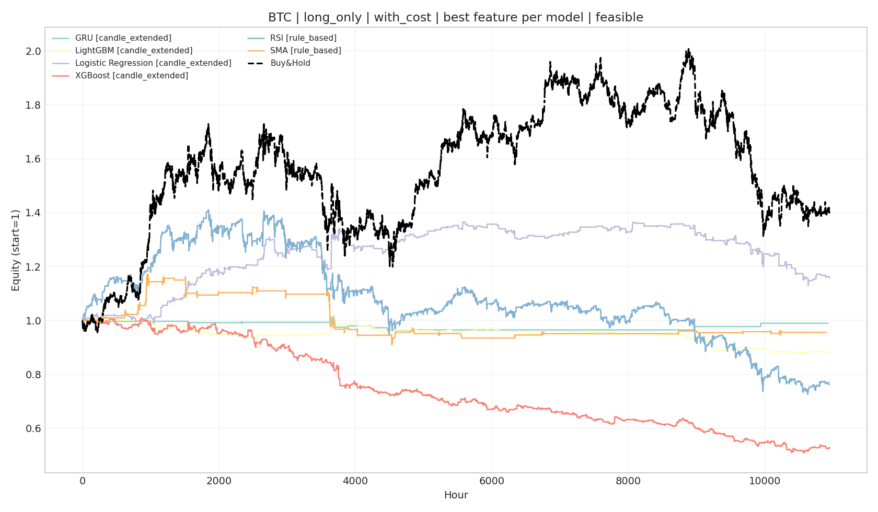 | 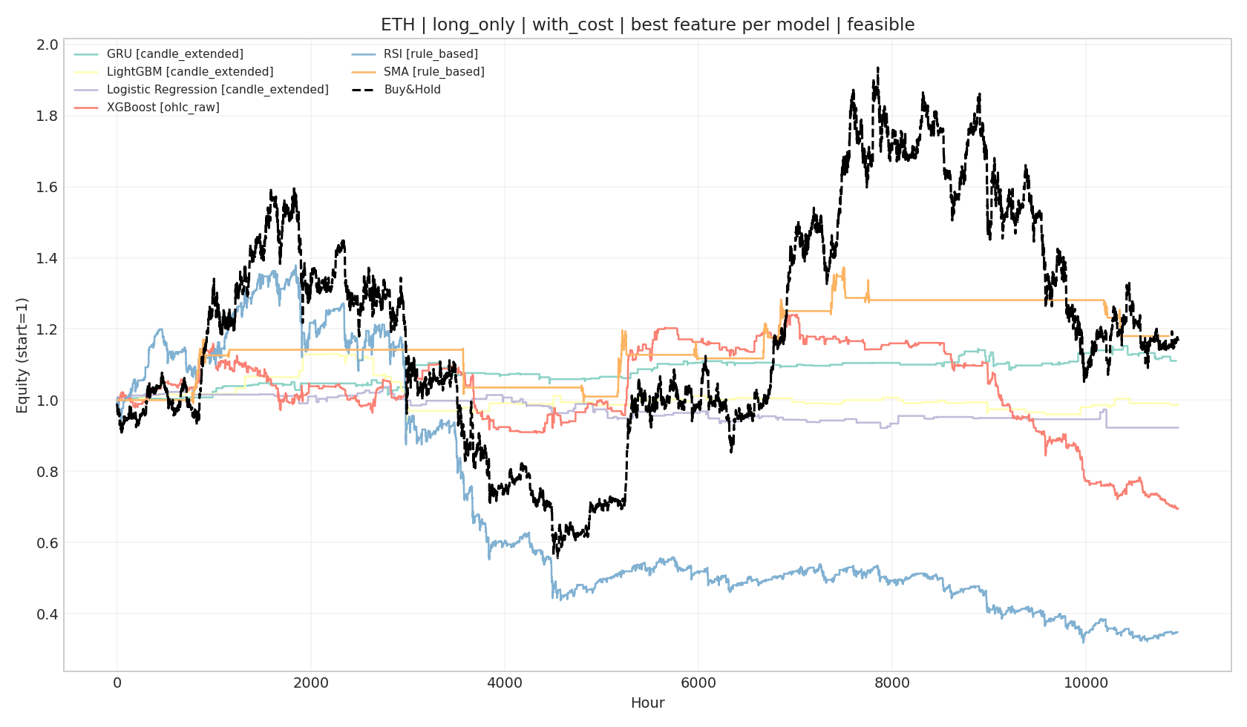
Figure 1. Bundled Equity Curves for BTC under Long-Only Strategy with Transaction Costs | Figure 2. Bundled Equity Curves for ETH under Long-Only Strategy with Transaction Costs
The equity curves further support these findings. For BTC, the buy-and-hold strategy maintains a strong upward trend, while most ML strategies remain flat or decline over time, indicating difficulty in overcoming trading costs.
For ETH, some ML strategies achieve moderate gains, suggesting the presence of short-term structure. However, performance remains inconsistent, with frequent drawdowns and no sustained outperformance relative to buy-and-hold.
Across other assets, similar patterns are observed. Active strategies may capture local trends, but consistent dominance over passive strategies is not achieved. Overall, the equity curves confirm that while ML strategies can generate signals, they are not robust enough to outperform passive exposure once costs are considered.

Limitations
Our study is constrained by several limitations that impact the robustness and generalizability of our findings. The data scope is limited to hourly Binance data for only four assets, which may reflect exchange-specific liquidity and fees rather than broader market truths. Furthermore, the narrow asset universe and short time frame make it difficult to determine if the observed patterns hold across the wider cryptocurrency ecosystem.
Another concern is the statistical reliability, as some high-performing configurations trade infrequently, raising concerns about reliability of the results. Many engineered variables are also derived from the same underlying prices and trading activity, leading to feature redundancy and high collinearity, which may introduce instability and overfitting. Future work could use feature-selection procedures, regularization analysis, or dimension-reduction methods, such as PCA, to refine the model input space.

Conclusion
This study evaluates whether ML-based trading strategies can outperform rule-based technical heuristics and passive buy-and-hold benchmarks in cryptocurrency markets once realistic backtesting constraints and transaction costs are incorporated. Using hourly Binance data for BTC, ETH, XRP, and SOL from 2021 to 2025, we evaluated buy-and-hold, SMA, RSI, and four ML models under long-only, short-only, and long-short structures. The findings indicate that long-only strategies are the most robust, while the inclusion of 0.035% transaction fees significantly erodes the profitability of long-short and short-only configurations.
While GRU achieves the highest average test Sharpe in pooled long-only comparisons, LightGBM and Logistic remain competitive and are often more stable across assets. Feature design also played a critical role; while candlestick representations offer no clear advantage over OHLC inputs, extended technical indicators often improve performance, though the gains are not always statistically robust across all settings.
At the same time, the economic significance of active trading remains limited. Transaction costs materially reduce cumulative returns across all strategy classes, and much of the apparent edge observed in the no-cost setting is weakened or eliminated once realistic trading frictions are imposed. Although some ML configurations show useful absolute performance, especially in ETH and SOL, there is little statistical evidence that active strategies consistently outperform buy-and-hold. This is particularly evident in BTC and XRP, where passive exposure remains a difficult benchmark to beat.
Overall, the project contributes as a realistic and cost-aware comparative study rather than as evidence that ML consistently dominates passive cryptocurrency investing. The main takeaway is that ML can enhance signal generation in certain settings, but its practical economic value is highly sensitive to feature design and execution frictions, as well as asset classes. Future work can extend the study by broadening the exchange and asset coverage, employing advanced dimension reduction to further refine feature selection, and testing whether the current findings remain stable under more diverse market environments.

